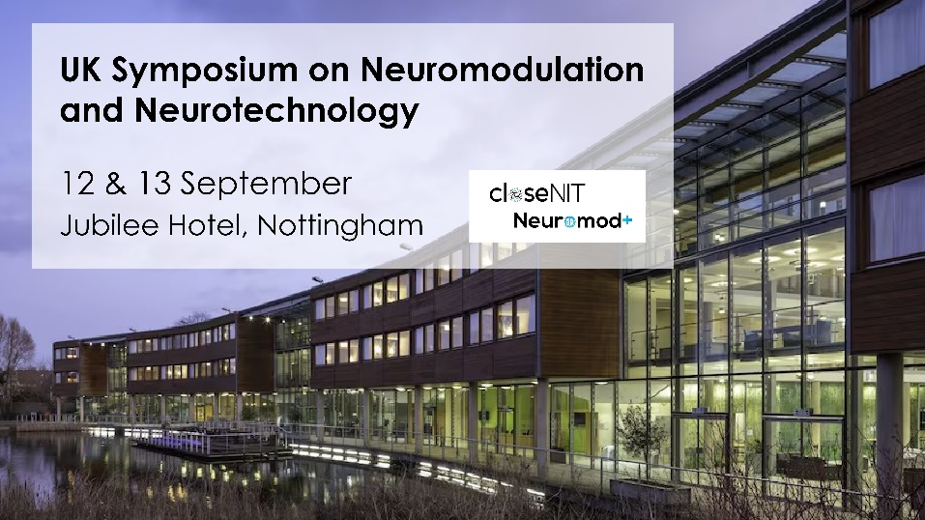
Code of conduct
We are committed to making our event productive and enjoyable for everyone, regardless of their background. To encourage honest discussion and exchange of ideas, and to make the event as inclusive and welcoming as possible, we ask all attendees to adhere to the points below:
- Be respectful of other participants; we expect discussion to adhere to high academic standards and to be conducted in a respectful manner
- Behave professionally. Harassment and sexist, racist, or exclusionary comments or jokes are not appropriate. Harassment includes sustained disruption of talks or other events, inappropriate physical contact, sexual attention or innuendo, deliberate intimidation, stalking, and photography or recording of an individual without consent. It also includes offensive or belittling comments related to gender, sexual orientation, disability, age, physical appearance, body size, ethnicity, or religion.
- All communication should be appropriate for a professional audience including people of many different backgrounds. Sexual language and imagery is not appropriate.
- Be kind to others. Do not insult or put down other attendees.
- Please bear in mind the spectrum of attendees present: patients, carers, PIs, postdocs, students, industry colleagues etc. Consider the power dynamic between different attendees and how it may affect interactions
- If someone makes you or anyone else feel unsafe or unwelcome, tell them so, remind them of the Code of Conduct and/or let the organisers know.

