Project Report: The Neurochemical Basis of Transcranial Focused Ultrasound Stimulation (FUS) on Memory
Investigators: Dr. JeYoung Jung (PI), Prof. Marcus Kaiser (Co-I), Prof. Matt Lambon Ralph (Collaborator)

1. Executive Summary
This project aimed to investigate and validate the effects of Transcranial Focused Ultrasound Stimulation (FUS) on human memory by elucidating its neurochemical mechanisms. Despite the promising clinical prospects of FUS, its impact on human cognition, particularly memory, and the underlying neurochemical changes, remained poorly understood. This report details the successful execution of a multimodal neuroimaging approach (MRS and fMRI) to address this critical knowledge gap. Through two distinct projects examining FUS effects, the research has delivered significant advancements, including a methodological gold standard for FUS control, compelling evidence of FUS-induced neurochemical, functional and morphological changes enhancing semantic memory, a prestigious research award, and widespread dissemination through invited talks at leading institutions.

2. Brief Methodology
The project comprised two main phases, both employing a "perturb-and-measure" approach, combining FUS with Proton Magnetic Resonance Spectroscopy (MRS) and functional Magnetic Resonance Imaging (fMRI) in healthy participants. The focus was on non-invasively measuring neurotransmitter levels (GABA and glutamate) and brain connectivity following FUS application.
Project 1 (offline effects): This phase focused on understanding the acute neurochemical and neural activity changes immediately following FUS. Participants (N=25) underwent FUS targeting specific brain regions (e.g., anterior temporal lobe, ATL) critical for semantic memory, followed by MRS and fMRI scans to capture instantaneous alterations.
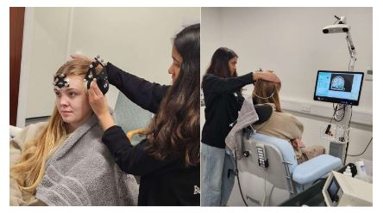
Figure 1. offline ATL FUS setting with brain navigation system.

Project 2 (online effects): Building on Project 1, this phase investigated the immediate and sustained effects of FUS on neurotransmitter systems and neural networks. Participants received FUS during fMRI, and follow-up MRS scans were conducted to assess persistent changes and their correlation with behavioural improvements in memory.
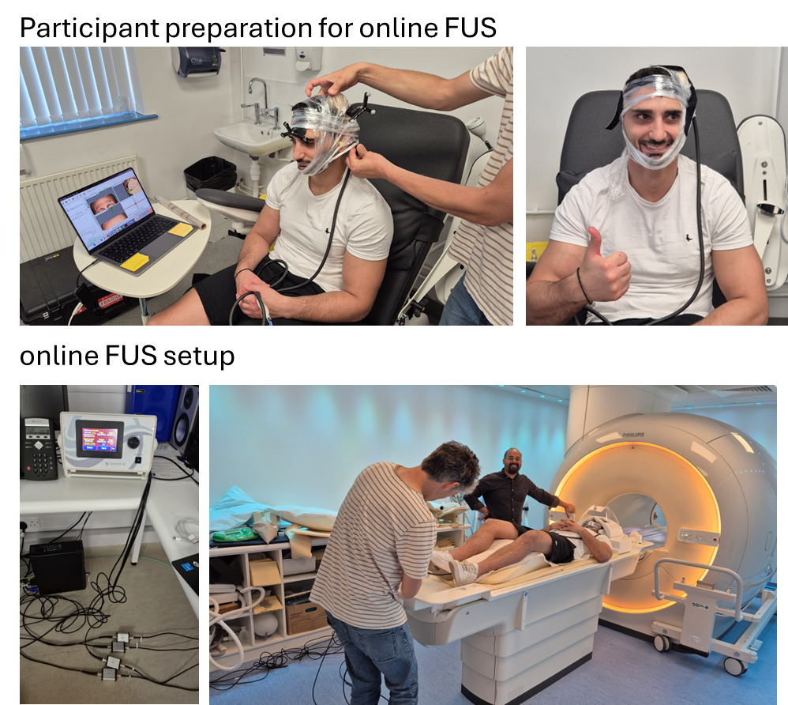
Figure 2. online FUS combined with multimodal imaging setup.

3. Impact of the Project
The project has generated substantial impact across several dimensions, pushing the boundaries of neuromodulation for cognitive enhancement and laying crucial groundwork for future dementia treatments.
3.1 Scientific & Methodological Impact
- Establishment of a Gold-Standard Control: The publication "Ventricle stimulation as a potential gold-standard control stimulation site for transcranial focused ultrasound stimulation" in Brain Stimulation represents a pivotal methodological contribution. A significant challenge in FUS research is the lack of a reliable control site that mimics the sensory experience of FUS without modulating neural tissue. Identifying ventricular stimulation as such a control vastly improves the rigor and interpretability of future FUS studies, enhancing the reliability of findings across the field. This directly addresses the need for robust, evidence-based FUS protocols.
- Mechanistic Understanding of Memory Enhancement: The preprint "Transcranial focused ultrasound stimulation of the anterior temporal lobe enhances semantic memory by modulating brain morphology, neurochemistry and neural dynamics" provides groundbreaking insights into how FUS affects memory. By demonstrating FUS-induced modulation of brain morphology, neurochemistry (GABA/glutamate levels), and neural dynamics within the anterior temporal lobe, the project has uncovered the neurochemical mechanisms underlying cognitive enhancement. This multi-modal evidence bridges the gap between FUS application and behavioural outcomes, fulfilling objective (1) of understanding neurochemical mechanisms.
- Advancing Personalized Treatment Protocols: The project's findings provide critical information for predicting FUS outcomes based on individual neural characteristics (objective 2) and developing evidence-based protocols (objective 3). By establishing links between FUS parameters, neurochemical changes, neural activity, and memory function, the research moves closer to designing personalized FUS interventions that could optimize efficacy and minimize side effects, a cornerstone of responsible innovation.
3.2 Recognition & Dissemination Impact
- Award-Winning Research: Receiving the "Best Research Poster Award" at the Brainbox Initiative Conference 2024 for "Enhancing Semantic Memory With Transcranial Focused Ultrasound Stimulation of the Anterior Temporal Lobe" signifies peer recognition of the novelty, quality, and potential impact of the findings. This award enhances the visibility of the research within the neuromodulation community.
- Widespread Expert Dissemination: The five invited talks at highly reputable institutions and societies (Imperial College London, MRC CBU University of Cambridge, Sheffield University, Korea University in South Korea, the British Neuropsychology Society 2024, and Brainbox initiative internation conference 2025) are a testament to the project's groundbreaking nature and its influence on the wider scientific community. These invitations indicate that the work is considered cutting-edge, contributing significantly to current discussions and future directions in neuroscience and neuromodulation. The international invitation to Korea University and Brainbox initiative further highlights the global recognition of this work.
3.3 Translational & Societal Impact
- Affecting millions globally, dementia represents an immense societal challenge with no current cure. By providing a mechanistic understanding of FUS effects on memory and developing initial protocols, this project has laid crucial groundwork for developing a novel, non-invasive therapeutic tool for dementia. The explicit aim to translate these protocols into large-scale clinical trials (with a view to MRC, NHIR, and ARUK funding) demonstrates a clear pathway towards patient benefit.

4. Contribution to Neuromod+ Network Aims
The Neuromod+ network is dedicated to fostering innovation and collaboration in the field of neuromodulation to address significant neurological and psychiatric conditions. This project has substantially furthered the aims of the Neuromod+ network in several key ways:
- Developing Novel Neuromodulation Techniques: The project has been at the forefront of investigating FUS, a cutting-edge, non-invasive brain stimulation technique, for cognitive enhancement. This directly contributes to the network's aim of exploring and validating new neuromodulation modalities.
- Unravelling Mechanisms of Action: A core challenge in neuromodulation is understanding how these techniques work. This project's focus on elucidating the neurochemical (GABA, glutamate) and neural dynamic mechanisms underlying FUS effects on memory provides critical insights that are essential for optimizing neuromodulation protocols and predicting treatment response, a key aim of Neuromod+.
- Translation of Research to Clinical Application: The project's clear pathway towards translating developed FUS protocols into clinical trials for dementia directly aligns with Neuromod+'s mission to move research from the bench to the bedside, ultimately impacting patient care.
- Advancing Methodological Rigor: The development of a potential "gold-standard" control stimulation site for FUS significantly enhances the methodological rigor of future neuromodulation studies, a principle strongly advocated by Neuromod+ for robust and reproducible research.

